CURRICULUM VITEA
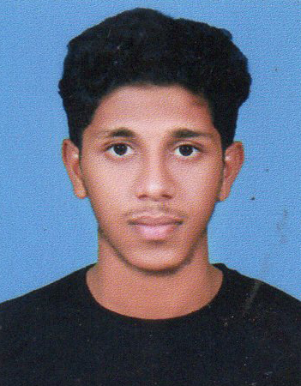
ARSHAD M K
Contact No: +91 9744658488
e-mail: mkarshad099@gmail.com

CAREER OBJECTIVE
Looking forward to a challenging and creative career in a competitive organization that will provide me with an opportunity to learn new technology, grow professionally by analytical and project management skills while contributing my best for the organization.
ACADEMIC QUALIFICATIONS

- Graduation: 2016-2019 Bsc Computer Science with the Percentage (First Class) From I H R D Muthavallur College, Malappuram

- Intermediate: 2014-2016 Completed HSE Science with the Percentage (80%) from G.H.S.S Peruvallur, Malappuram

- Matriculation: 2014 S.S.L.C with the percentage (86%), From P P M H S S Kottukkara, Malappuram

PROFESSIONAL SKILL

- Good Communication Skills & Quick Learner
- Hard working and Result Oriented
- Work with multicultural circumstances
COMPUTER PROFICIENCY

- Computer Hardware & Repairing.

- Office Package: Microsoft Word, Excel, Power Point and Internet and Email.

- Computer Language: Python, C, C++, JAVA,

- Basic knowledge’s of Internet, Html etc

PERSONAL SKILLS
- Marketing Skill
- Good ability to solve the problems in the work.
- Determination towards work.
- Punctuality.
- Creativity and ability to reach the expected height
- Good organizational skills.

PERSONAL DETAILS

Name : ARSHAD M K
Father’s name : VEERAN KUTTY M K
Date of birth : 16-06-1998
Nationality : INDIAN
Gender : MALE
Blood : A^{+VE}
Marital status : SINGLE
Languages known : Malayalam (mother tongue)
English, Hindi, ARABIC
Permanent Address : MANE PALLIYALI HOUSE
CHATHRATHODI
PARAMBIL PEEDIKA (PO)
MALAPPURAM (DIST)
KERALA-676317

DECLARATION

I hereby declare that the information furnished above is true to the best of my knowledge and belief.

Place: PARAMBIL PEEDIKA ARSHAD M K

Date:

